**A Mini Project on**

**ONLINE LIBRARY MANAGEMENT SYSTEM**

**By**

**K.Vamshi Chander.**

**Project Guide : MD.Ismail.**

**Sign of Project Guide**

**ABSTRACT**

**Abstract:**

The project titled Library Management System is Library management software for monitoring and controlling the transactions in a library. The paper "Library Management System" is developed in java which mainly focuses on basic operations in a library like adding new member, new books, and updating new information, searching books and members and facility to borrow and return books. "Library Management System" is a windows application written for 32-bit Windows operating systems, designed to help users maintain and organize library. This software is easy to use for both beginners and advanced users.

**Introduction to the project:**

The purpose of the application is automation of library ,it provide facilities to student or member to search for the required books and it allows the administrator or librarian to Issue & return books to students and can create & delete membership of students. The software Library Management System has four main modules. Insertion to Database Module - User friendly input screen Extracting from Database module - Attractive Output Screen Report Generation module - borrowed book list & Available book list Search Facility system - search for books and members

**Existing System :**

The Present system manages all library information across ledgers and files. Maintenance all data related to books,

borrowers and librarians id done manually using conventional procedures. These methods are not effective and lead to mis management of data. It is difficult for a user to check availability of a book and to make reservations.

**Disadvantages:**

Some of the problems faced in manual system are as follows:

1. Fast report generation is not possible
2. Tracing a book is difficult
3. Information about issue/return of the books are not properly maintained.
4. No central database can be created as information is not available in database

**Proposed System:**

Proposed system is an automated Library Management System. Through our software user can add members, add books, search members, search books, update information, edit information, borrow and return books in quick time. Our proposed system has the following advantages.

**Advantages:**

1. It provides better and efficient service to members.
2. It is the online system that can be operated from anywhere.
3. User can enquire about the book without going to the library.
4. Reduce the workload of employee.
5. Faster retrieval of information about the desired book.
6. All details will be available on a single click.

**Feasibility Report :**

The main objective of the feasibility study is to test the Technical, Operational and Economical, feasibility for adding new modules and debugging old running system. There are aspects in the feasibility study portion of the preliminary investigation:

1. Technical Feasibility
2. Operational Feasibility
3. Economical Feasibility

**Technical Feasibility :**

Evaluating the technical feasibility is the trickiest part of a feasibility study. This is because, at this point in time, not too many detailed design of the system, making it difficult to access issues like performance, costs on (on account of the kind of technology to be deployed) etc. A number of issues have to be considered while doing a technical analysis.

**Operational Feasibility :**

Proposed projects are beneficial only if they can be turned into information systems that will meet the organizations operating requirements. Simply stated, this test of feasibility asks if the system will work when it is developed and installed. Are there major barriers to implementation.

**Economical Feasibility :**

Economic feasibility attempts to weigh the costs of developing and implementing a new system against the benefits that would accrue from having the new system in place. The feasibility study gives the top management the economic justification for the new system.

**Software Requirements :**

Operating System : Windows Family or Linux

User Interface : HTML, CSS

Client-side Scripting : Javascript

Programming Language : Java

Web Applications : JDBC, Services,JSP

IDE/Workbench : My Ecllipse

Database : Oracle 10g

Server Deployment : Tomcat 6.x

**Hardware Requirements :**

Processor : Pentium IV

Hard Disk : 40GB

RAM : 1GB or more

**SYSTEM ANALYSIS**

**Introduction :**

Library management system is a project which aims in developing a computerized system to maintain all the daily work of library. This project has many features which are generally not available in normal library management systems like facility of user login and afacility of teacher’s login. It also has a facility of admin login through which the admin can monitor the whole system. It also has facility of an online notice board where teachers can student can put up information about workshops or seminars being held in our colleges or near colleges and librarian after proper verification from the concerned institution organizing the seminar can add it to the notice board. It has also a facility where student after logging in their

accounts can see list of books issued and its issue date and return date and the students can request the librarian to add new books by filling the book request form. The librarian after logging into his account i.e., admin account can generate various reports such as student report, issue report, teacher report and book report Overall this project of ours is being developed to help the students as well as staff of library to maintain the library in the best way possible and reduce the human efforts.

**Description of Modules :**

After careful analysis the system has been identified to have the following modules:

1. Librarian Module

2. Faculty Module

3. Student Module

**1. Librarian module**

The librarian is the administrator who manages the application. Librarian can add

edit and update details of books. As soon as a reservation is made for a particular book, an automatic mail should be sent to the person who made the reservation about the details. Then, a mail should be sent to people who are having the book currently, stating a reservation has been made on that book.

**2. Faculty module :**

Faculty should be able to login to the system and change the password. Faculty should see the status of the books/journals borrowed/reserved by him and the respective due dates and other relevant details. Faculty can search for a particular book/journal based on the name of the book/name of the author/subject/etc and also list for books/journals based on the name of the author/subject etc. Faculty can place requests for purchasing new books to the library, by giving details about the name of the book, name of the author, publisher. Faculty can cancel the

reservation made earlier for a particular book/journal. Faculty can reserve a particular book/journal borrowed by others currently.

**3.Student module :**

A student should be able to login to the system through the first page of the application and change the password after login into the system. A student can view the status of the books and journals borrowed or reserved by him and the due dates. Students can search for a particular book or journal based on the name of the book or name of the author or subject. Students can cancel the reservation made earlier for a particular book/journal Students can reserve a particular book

**SOFTWARE REQUIREMENTS SPECIFICATION**

**Functional Requirements**

**1. Introduction**

This project is aimed at developing an Online Library Management System (OLMS) for the college library. This is an Internet based application that can be accessed throughout the campus.

**1.1 Purpose**

The purpose of developing Online Library Management System is used to search for books/magazines, reserve books, find out who is having a particular book, put in requests to buy a new book etc.

**1.2 Scope**

The scope of the Online Library Management System is as follows:

This is one integrated system that contains both the user component and the librarian component

There are features like email notifications or reminders, report generators etc in this system.

**1.3 References**

* Java Complete Reference by Herbert Shield
* Wikipedia, URL: <http://www.wikipedia.org>
* Answers.com, Online Dictionary, Encyclopedia and much more,

URL: http://www.answers.com

**1.4 Technologies to be used**

* HTML, CSS (Web Presentation)
* JavaScript (Client-side Scripting)
* Java (as programming language)
* JDBC, JNDI, Servlets, JSP (for creating web applications)
* Eclipse with My Eclipse Plug-in (IDE/Workbench)
* Oracle/SQL Server/Access (database)
* Windows XP (Operating System)
* Tomcat (Server Deployment)

**1.5 Overview**

Overall description consists of background of the entire specific requirement.It also gives explanation about actor and function which is used. It gives explanation about architecture diagram and it also gives what we are assumed and dependencies. It also support specific requirement and also it support functional requirement, supplementary requirement other than actor which is used. It also gives index and appendices. It also gives explanation about any doubt and queries.

**SYSTEM DESIGN**

**UML Diagrams :**

The Unified Modeling Language allows the software engineer to express an analysis model using the modeling notation that is govened by a set of syntactic semantic and pragmatic rules.

A UML system is represented using 'five different views that describe the system from distinctly different perspective. Each view is defined by a set of diagram, which is as follows.

* User Model View
* Structural model view
* Behavioral Model View
* Implementation Model View.

UML is specifically constructed through two different domains they are:

* UML Analysis modeling, this focuses on the user model and structural model views of the system
* UML design modeling, which focuses on the behavioral modeling, implementation modeling and environmental model views.

**USE CASE DIAGRAMS:**

Use-Case Diagrams are usually referred to as behavior diagrams used to describe a use cases that some system or systems (subject) should or can perform in collaboration with one or more extenal users of the system (actors). Each use case should provide some observable and valuable result to the actors or other stakeholders of the system.

A use case diagram at its simplest is a representation of a user's interaction with the system that shows the relationship between the user and the different use cases in which the user is involved. A use case diagram can identify the different types of users of a system and the different use cases and will often be accompanied by other types of diagrams as well.

**Main Use case Diagram:**

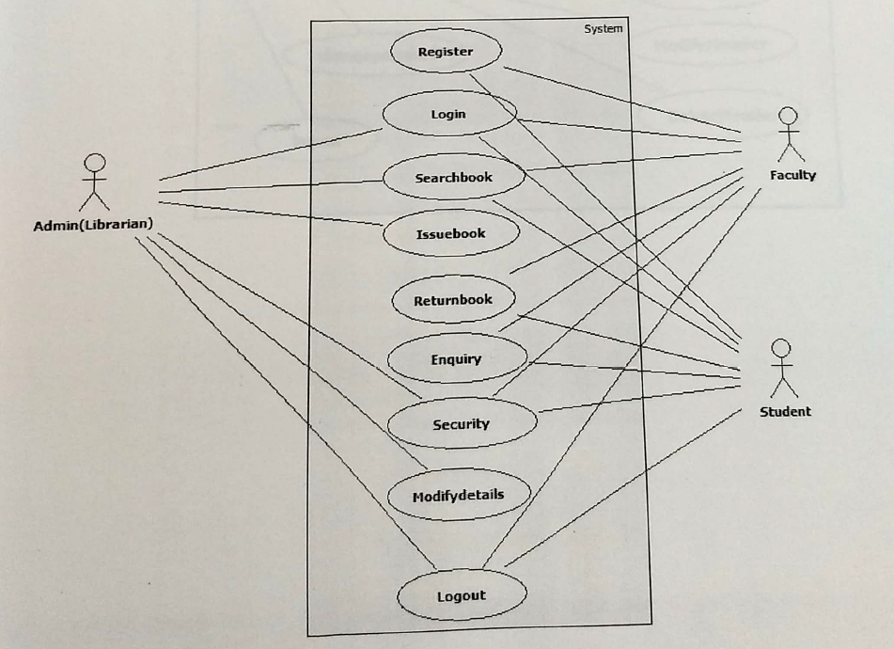

**Admin Use Case Diagram:**

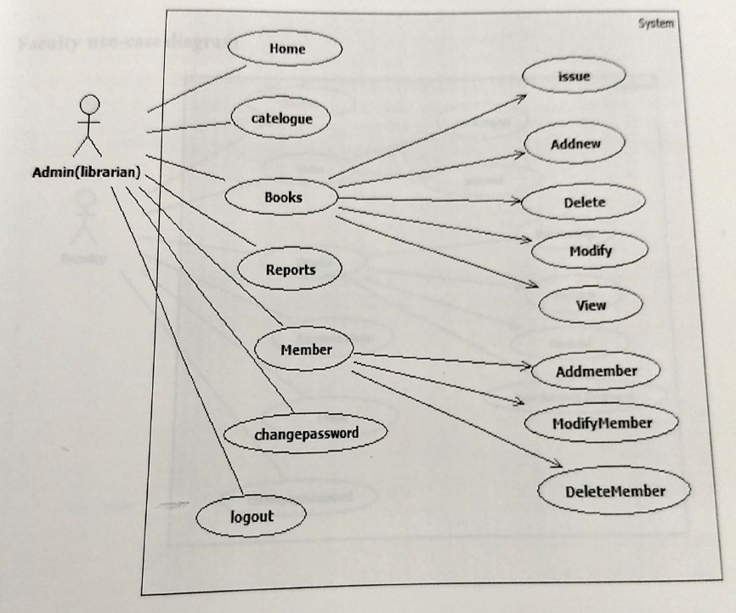

**Faculty Use case Diagram:**

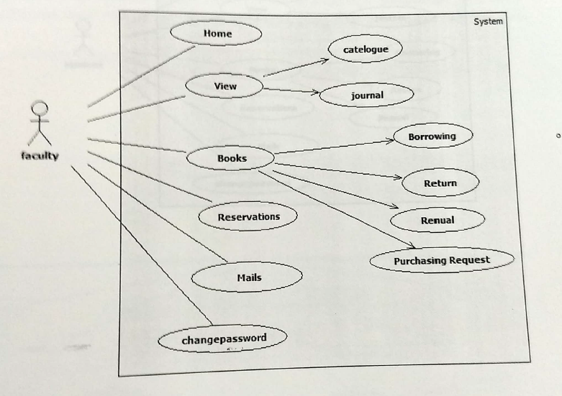

**Student Use Case Diagram:**

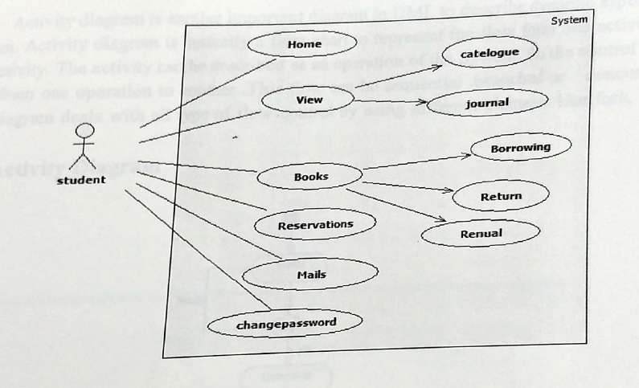

**Activity diagrams :**

Activity diagram is another important diagram in UML to describe dymamic aspects of the System. Activity diagram is basically a flow chart to represent the flow form one activity to another activity. The activity can be described as an operation of the System. So the control flow is drawn from one operation to another. This flow can be sequential .branched or concurrent.

Activity diagram deals with all type of flow control by using different elements like fork, join, etc.

**Admin Activity Diagram**

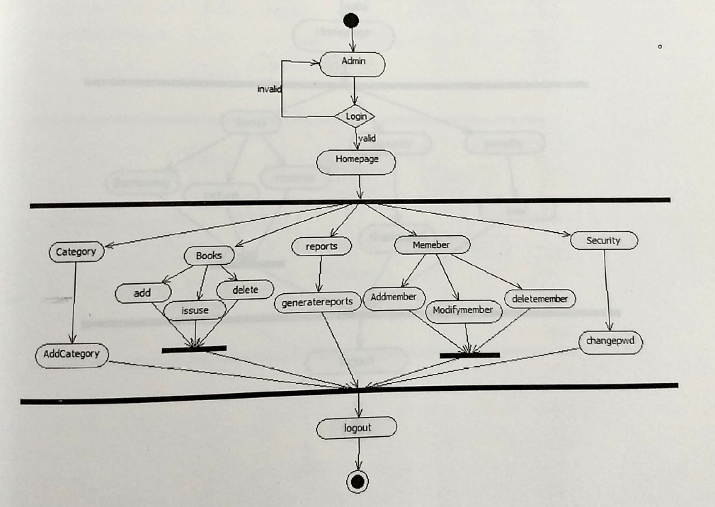

**Faculty Activity diagram:**

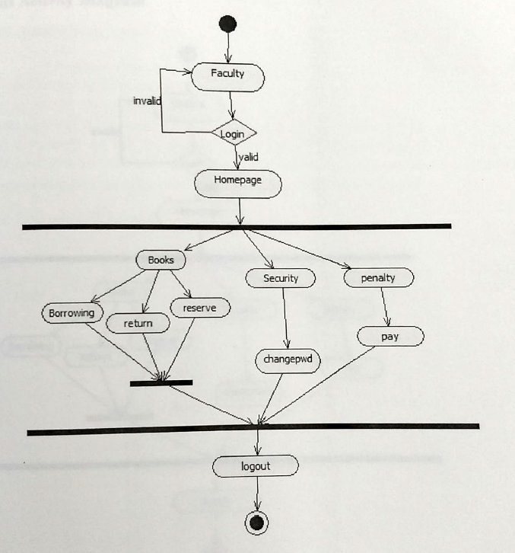

**Student Activity Diagram**

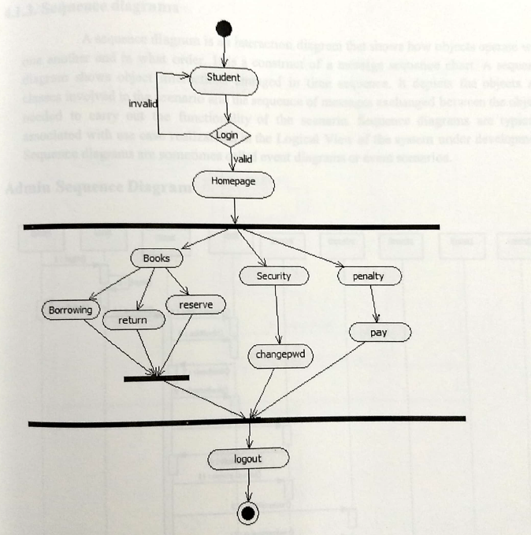

**Sequence Diagrams:**

A sequence diagram is an interaction diagram that shows how objects operate with one another and in what order. It is a construct of a message sequence chart. A sequence diagaram shows object interactions arranged in time sequence. It depicts the objects and classes involved in the scenario and the sequence of messages exchanged between the objects needed to carry out the functionality of the sccnario. Sequence diagrams are typically associated with use case realizations in the Logical View of the system under development

Scquence diagrams are sometimes called event diagrams or event scenarios.

**Admin Sequence Diagram:**

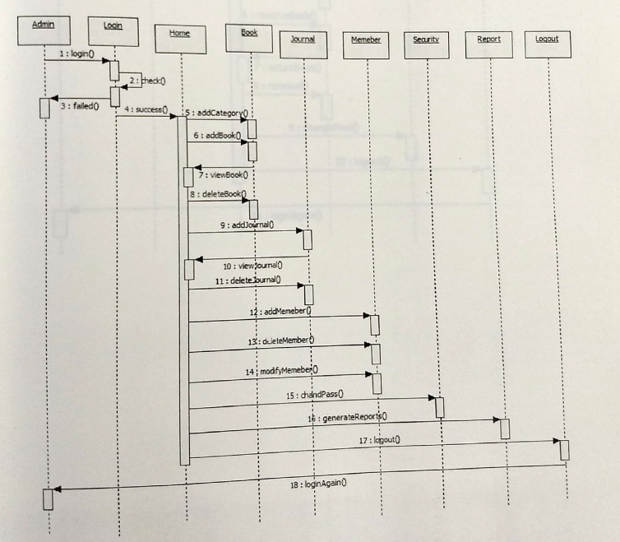

**Faculty Sequence Diagram:**

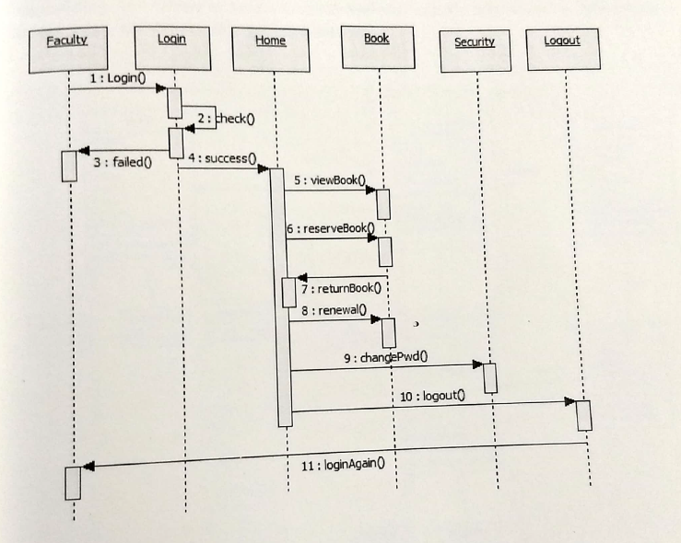

**Student Sequence Diagram:**

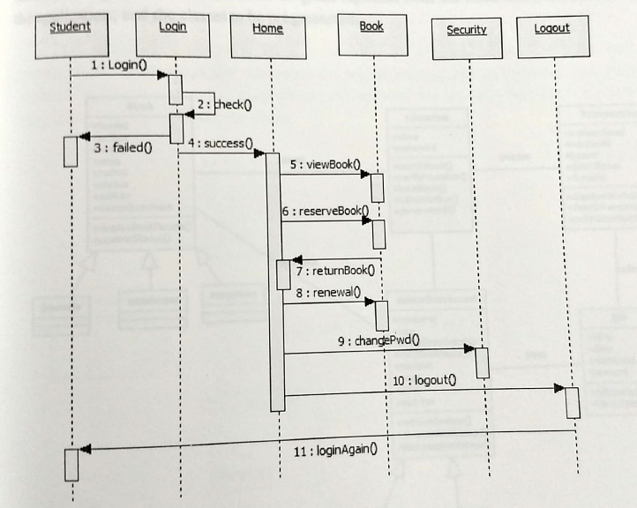

**Class Diagram:**

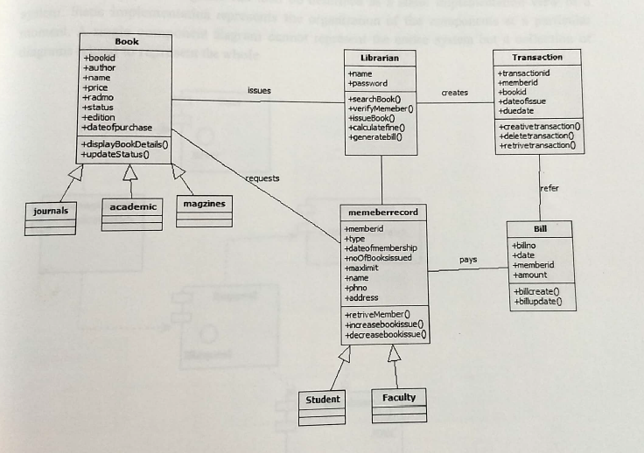

**Deployment Diagram:**

